Institutional Effectiveness Plan
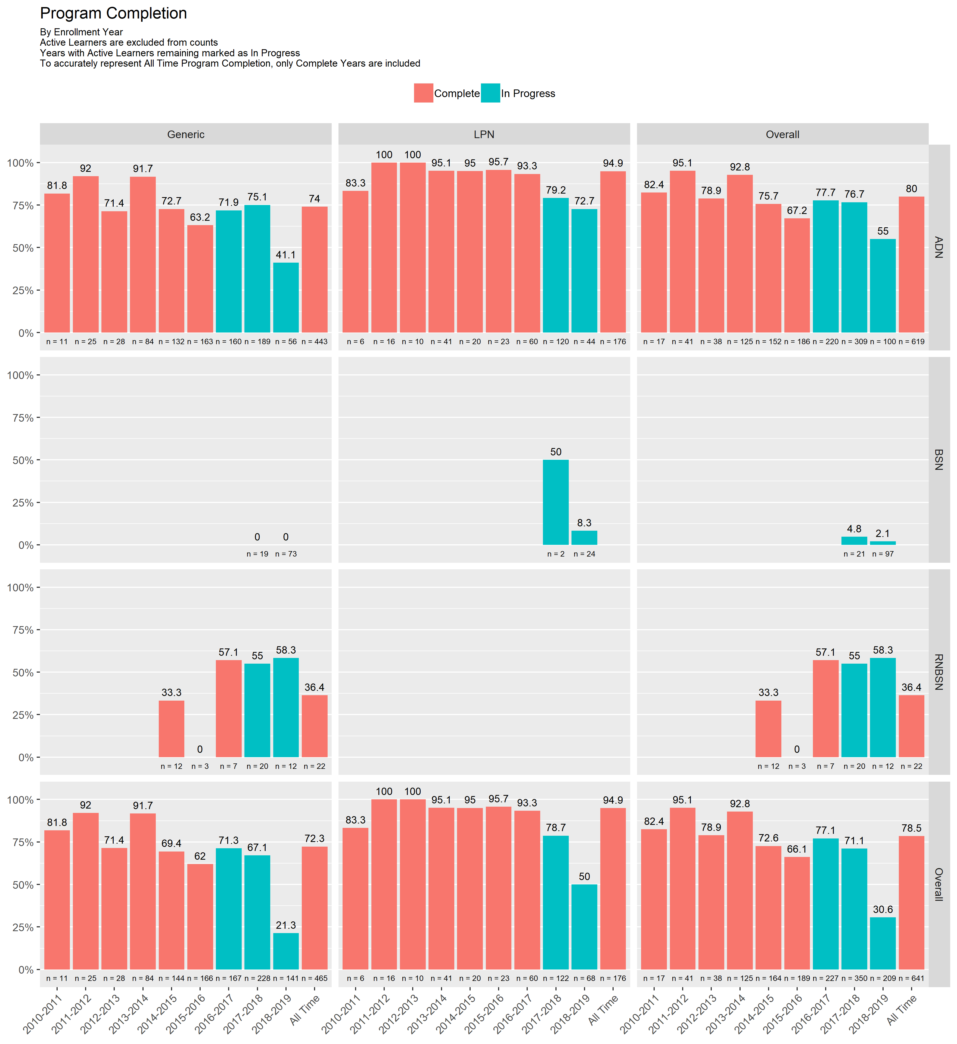
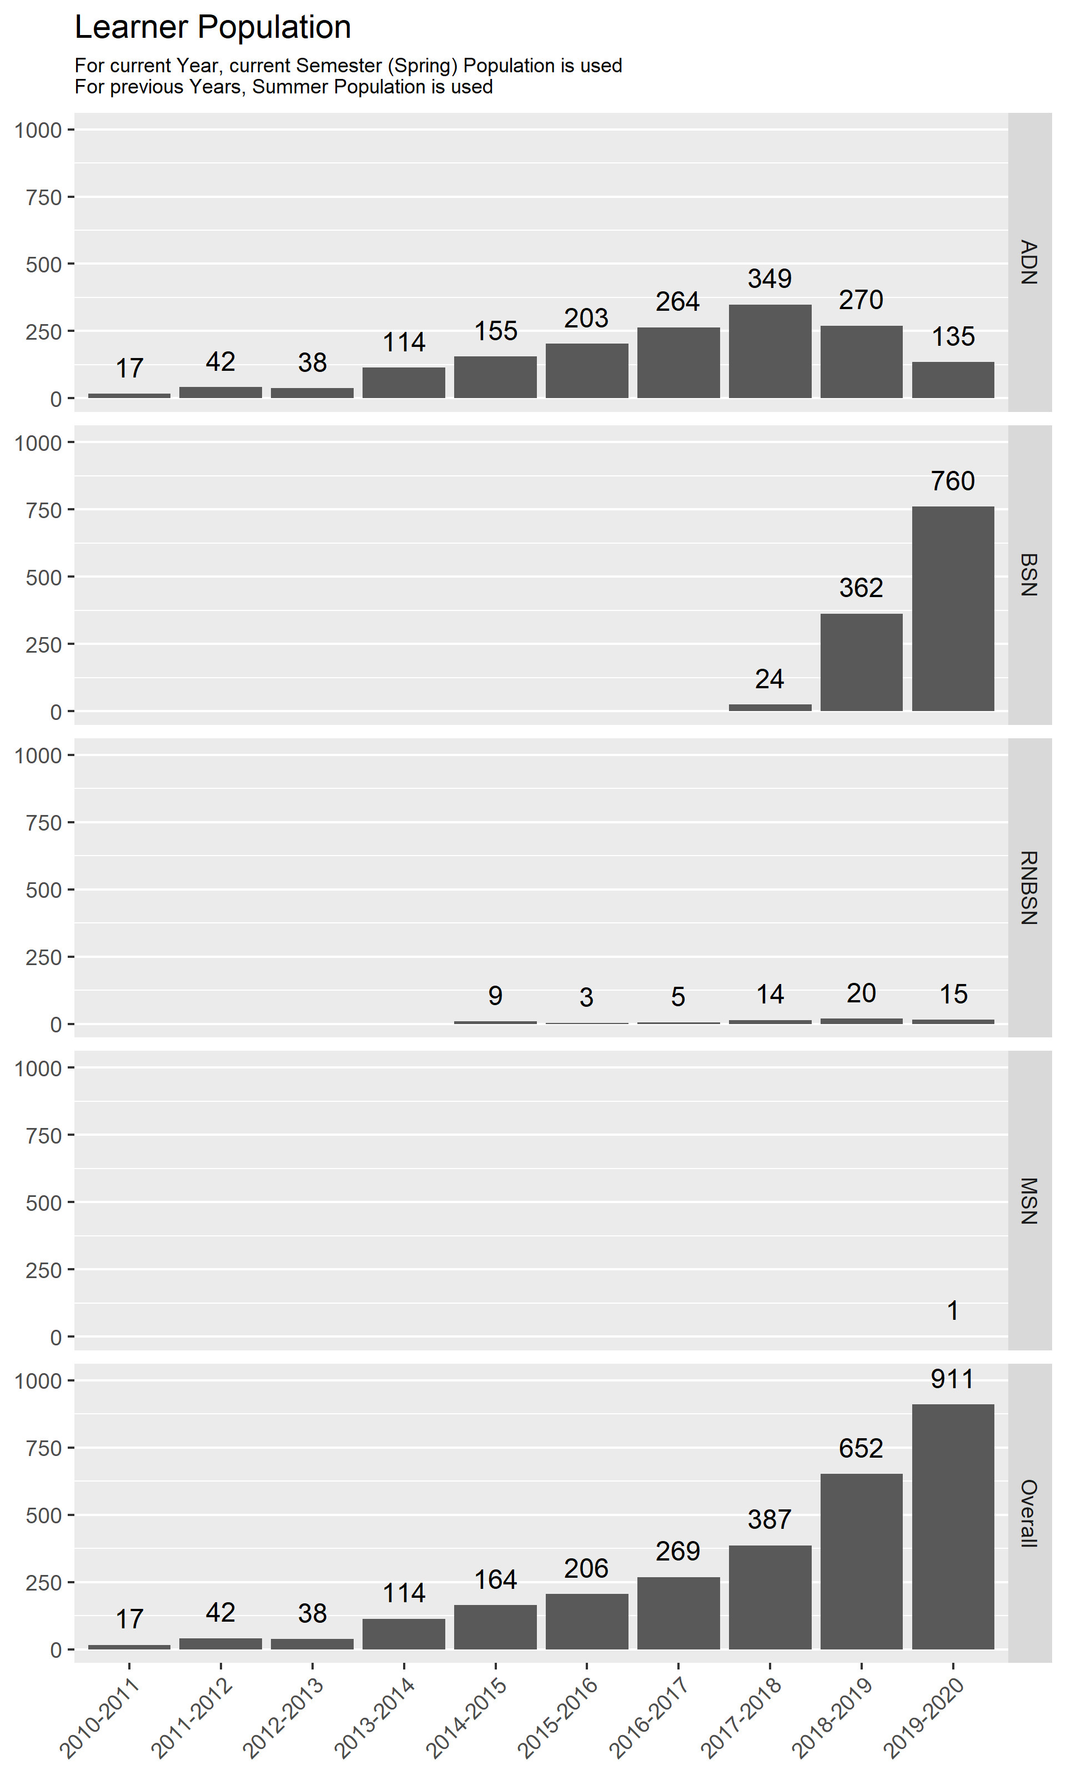
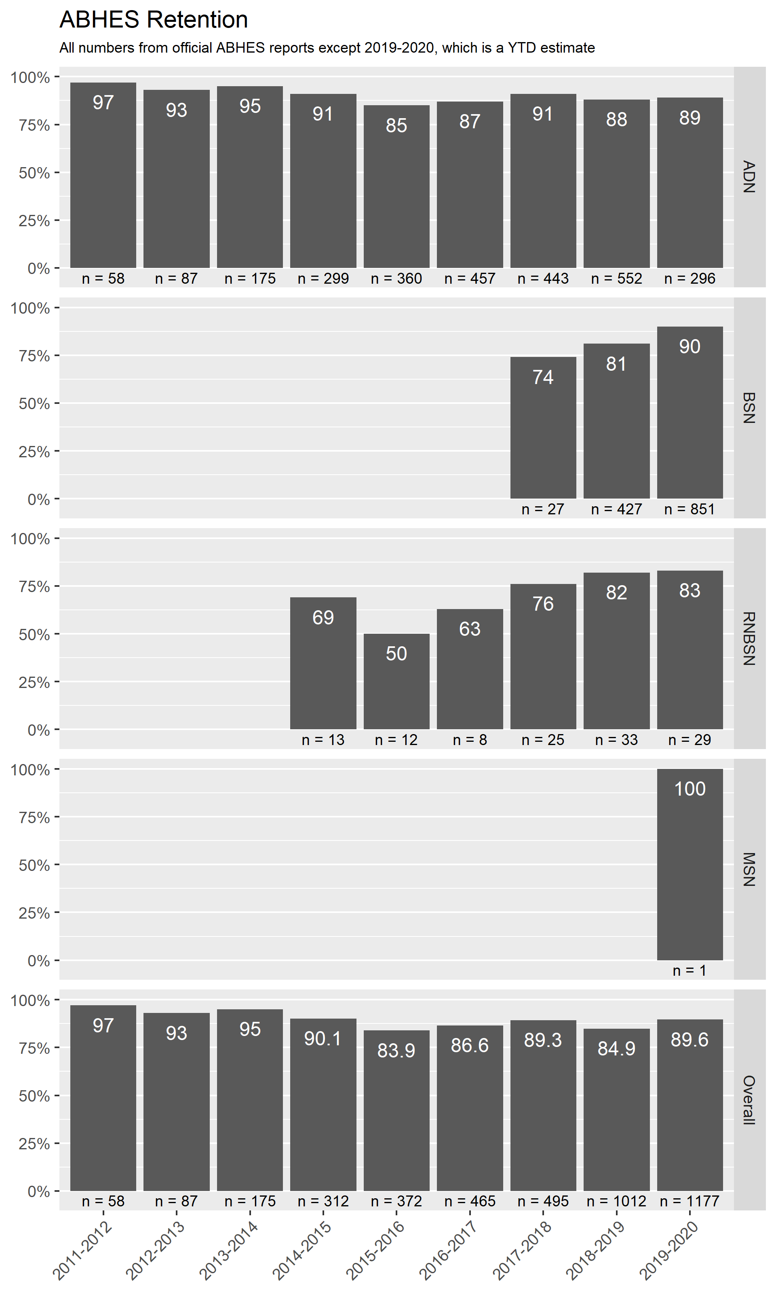
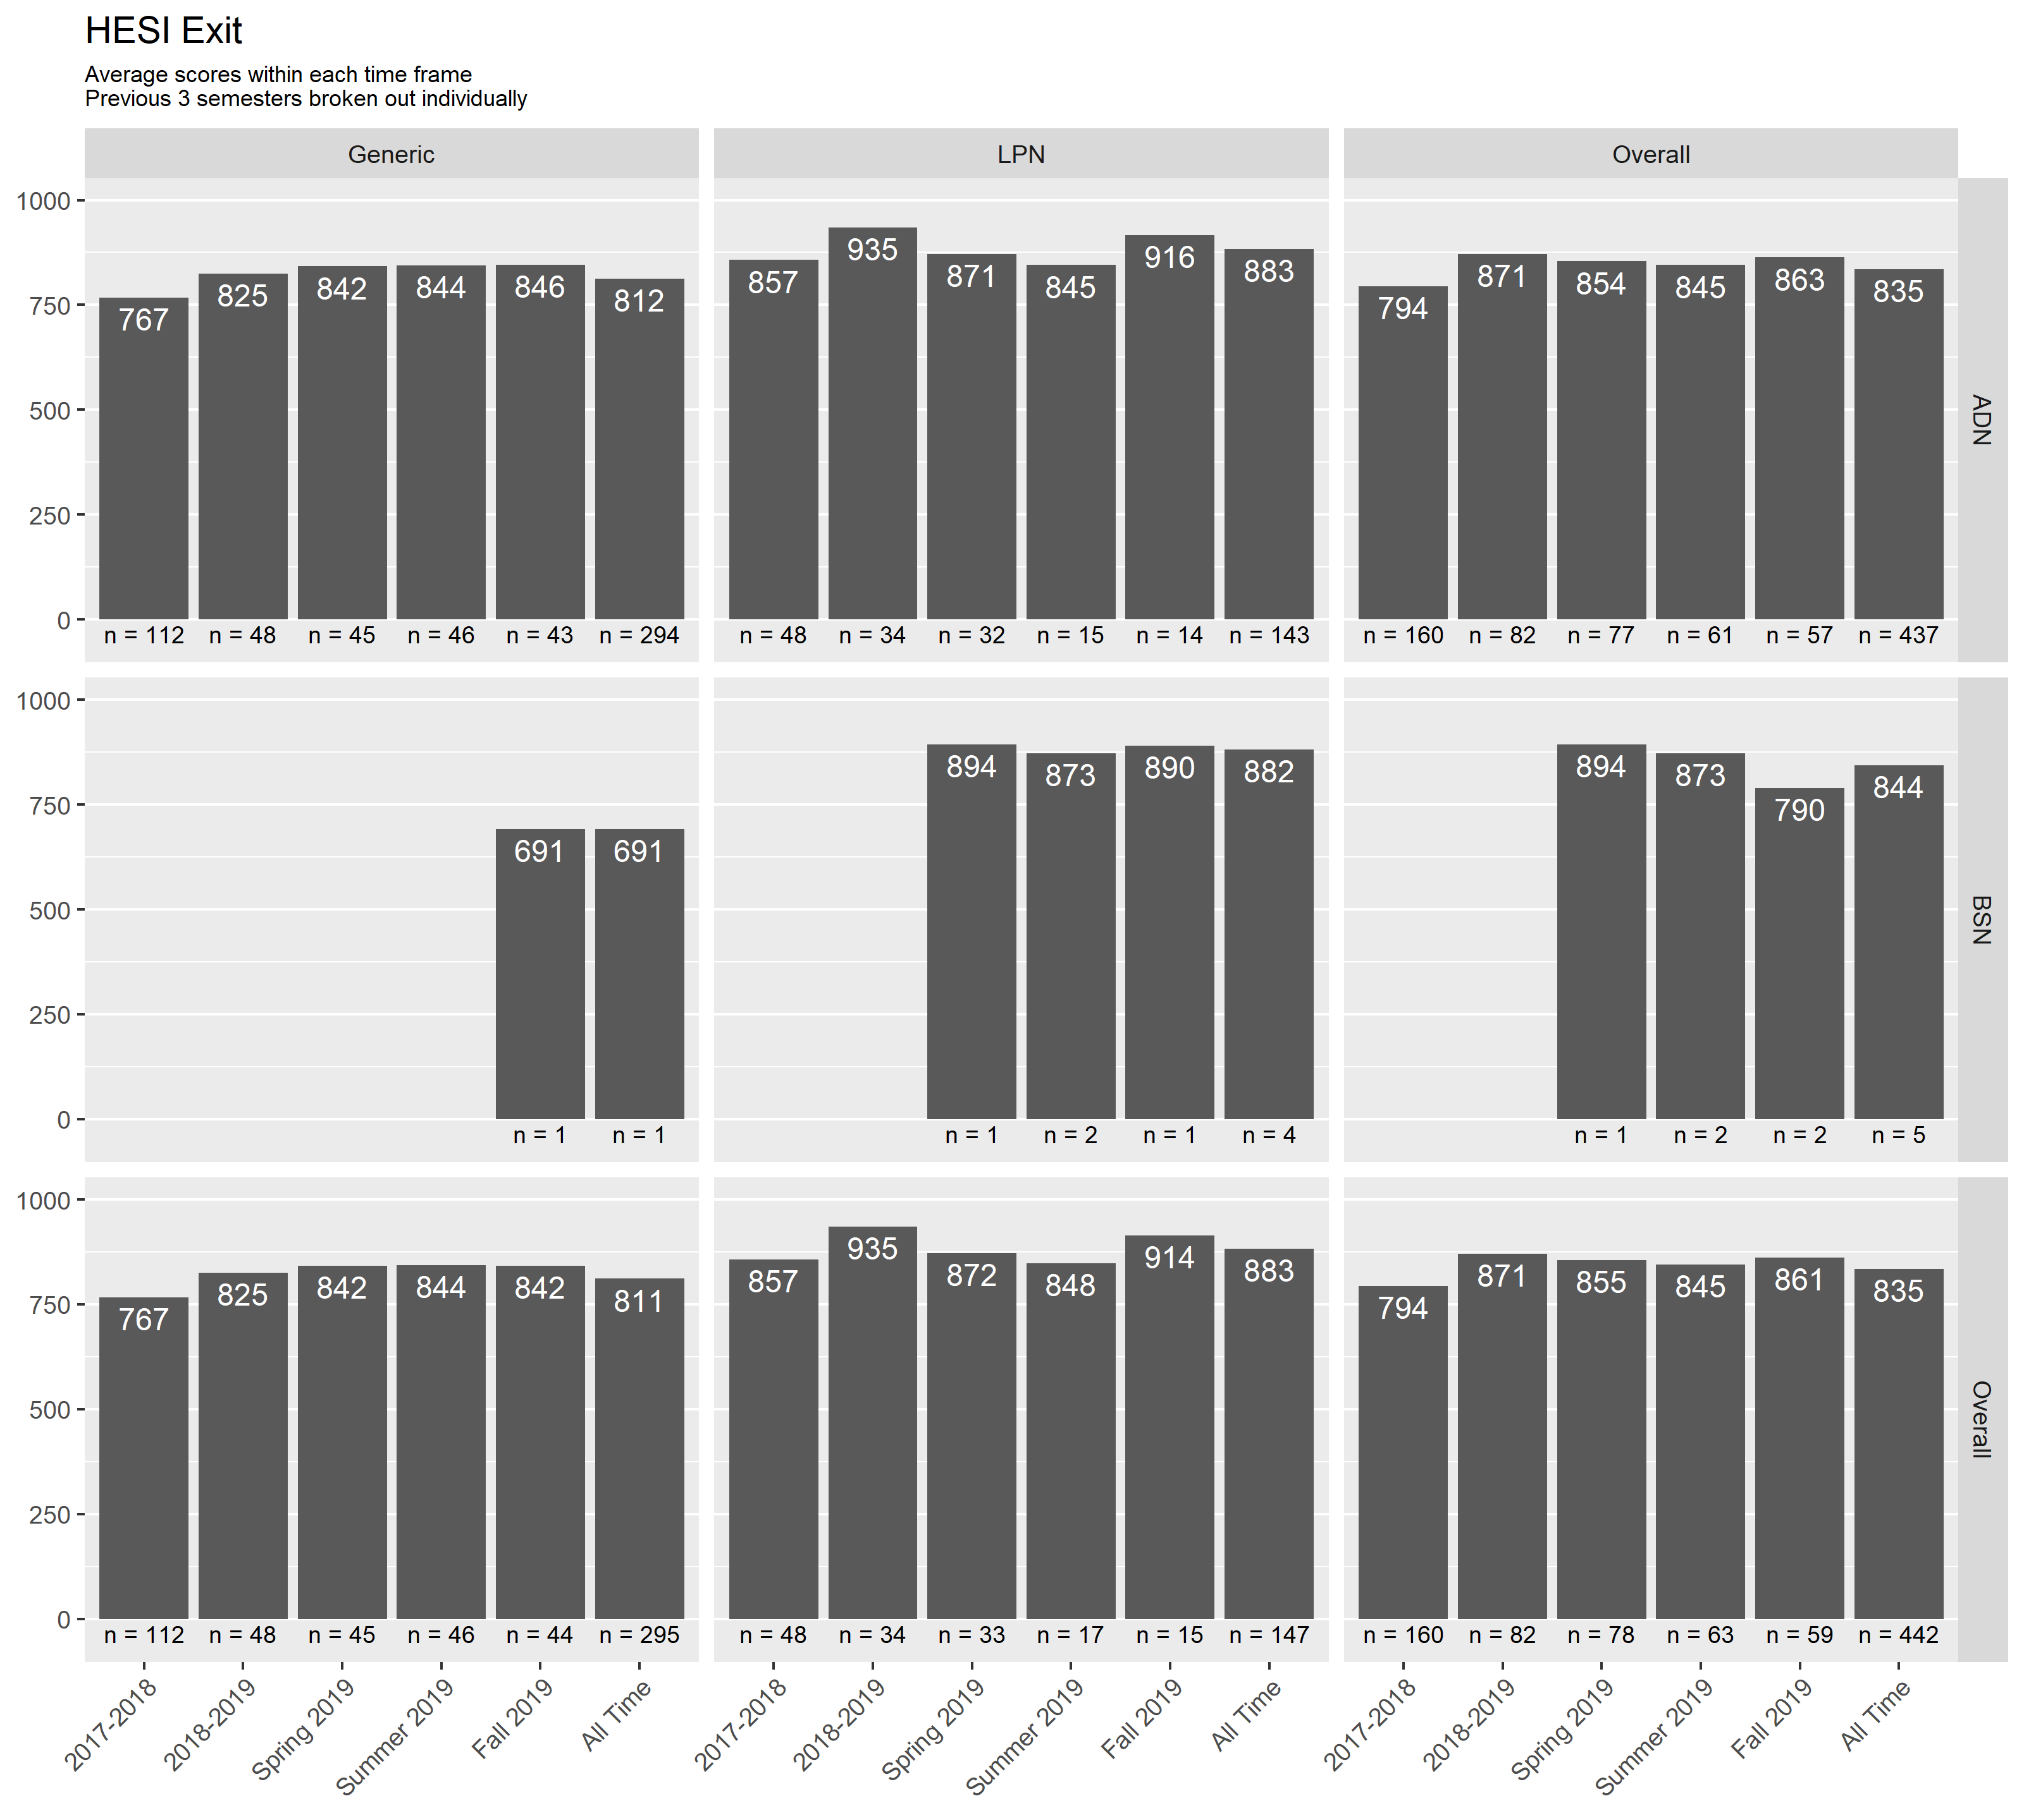
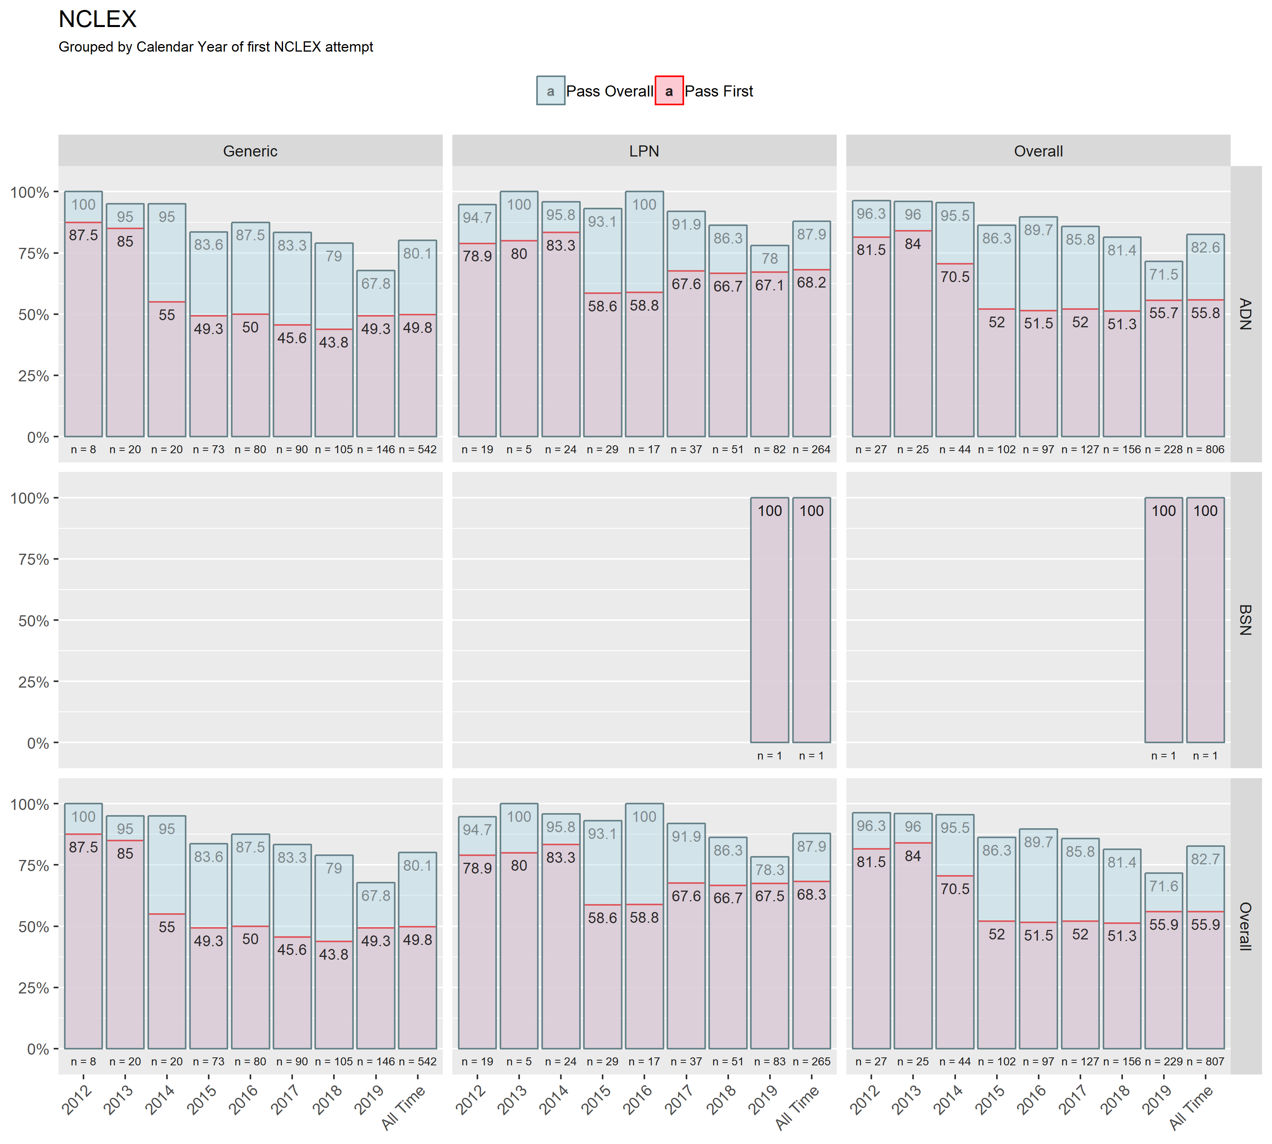

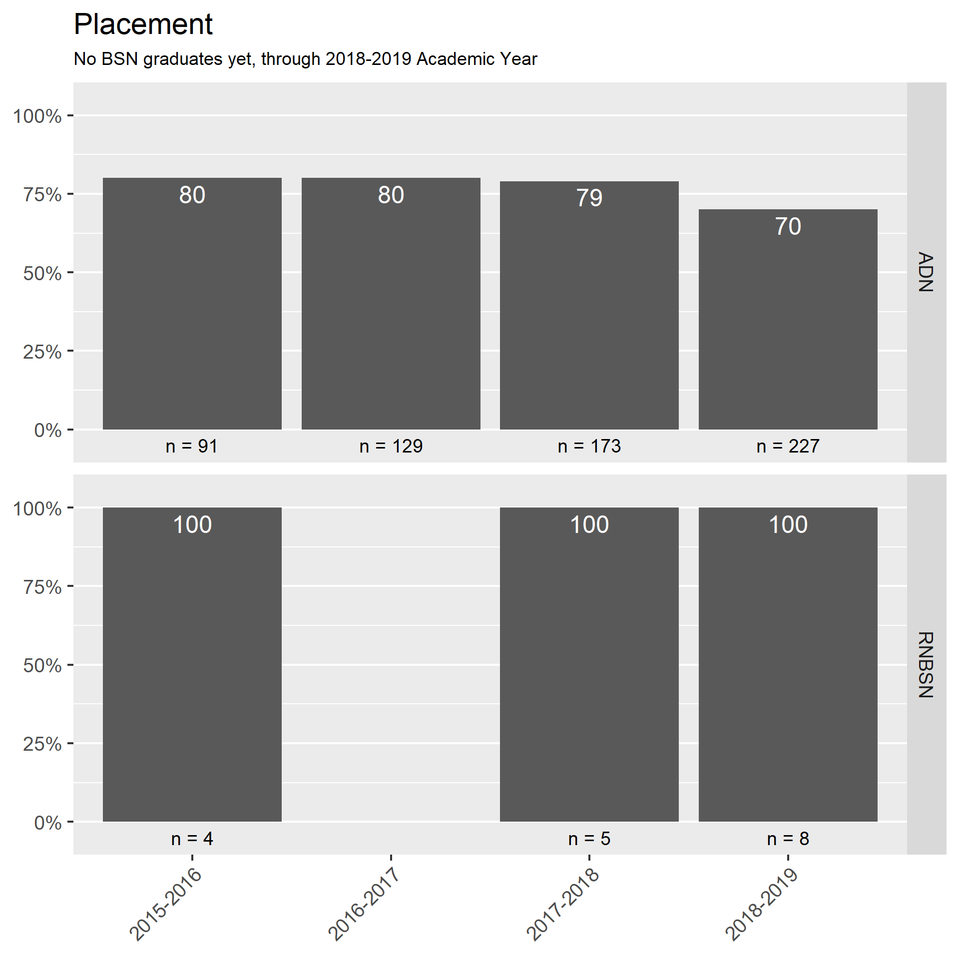

SUMMARY/ANALYSIS
- Program Completion
  - Active Learners excluded
  - $Grad Rate= \frac{Graduates}{Graduates+Withdrawals}$
  - In Progress years, particularly the most recent years, will continue to rise
    - This is especially true for BSN. The Grad Rate is skewed heavily downward because only Graduates and Withdrawals are counted. Until more time passes and more learners have a chance to graduate, this will continue to remain the case.

- Learner Population
  - Total term enrollments during Academic Year (non-unique, meaning if 1 learner was enrolled all 3 semesters, they would be counted 3x)
  - Our population continues to grow rapidly, especially BSN.

- Retention
  - Learners who continue towards graduation
  - So far for 2019-2020 we are looking great

- HESI Exit
  - Average HESI Exit score by program
  - We are up across the board so far in 2019-2020
  - LPNs show a significant difference

- NCLEX
  - Our first-time pass rate is slowly improving
  - Overall pass rate is deceiving and will improve over time as more learners re-attempt.
  - LPNs show a significant difference

- Placement
  - Similar to NCLEX Overall rate, Placements will continue to improve over time as well.

ACTION PLAN
- Starting in January until the program switch in ADN we are targeting LPN learners for that program, admitting already held LPN or significant advanced placement.
- Expanding the work on LPN Exit and NCLEX to aid in the restructure of the ADN.
- Detail the work being done to promote persistence to completion from pre-req work to LPN (looking at overall completion of program past anticipated completion goals).
- ADN restructure to include LPN progress through to ADN. Involves new curriculum paths, structure for support, and benchmarks for success.
- Continued work on refining the remediation plans, tutoring, NCLEX Coach structure, and LALR support processes to encourage retention and academic success.
- Late-work remediation policy change
- NCSBN practice tests implemented
- Effective January 2020, expanded learning resources
- Redesigning course audit process

GOAL
- Program Completion – 70%
- Learner Pop – Shift in the breakout to identify the average per-semester population trending in a given year and include year over year variance. 75% increase.
- Retention – 80%, structured to account for new policies, structures, programs, and requirements.
- HESI EXIT – 900
- NCLEX – All-time: 86%. 2019-2020: 75% by Nov 1, 2020, 85% by July 1, 2021
- Placement – 75% by Nov. 1, 2020, 85% by July 1, 2021

Institutional Effectiveness Plan
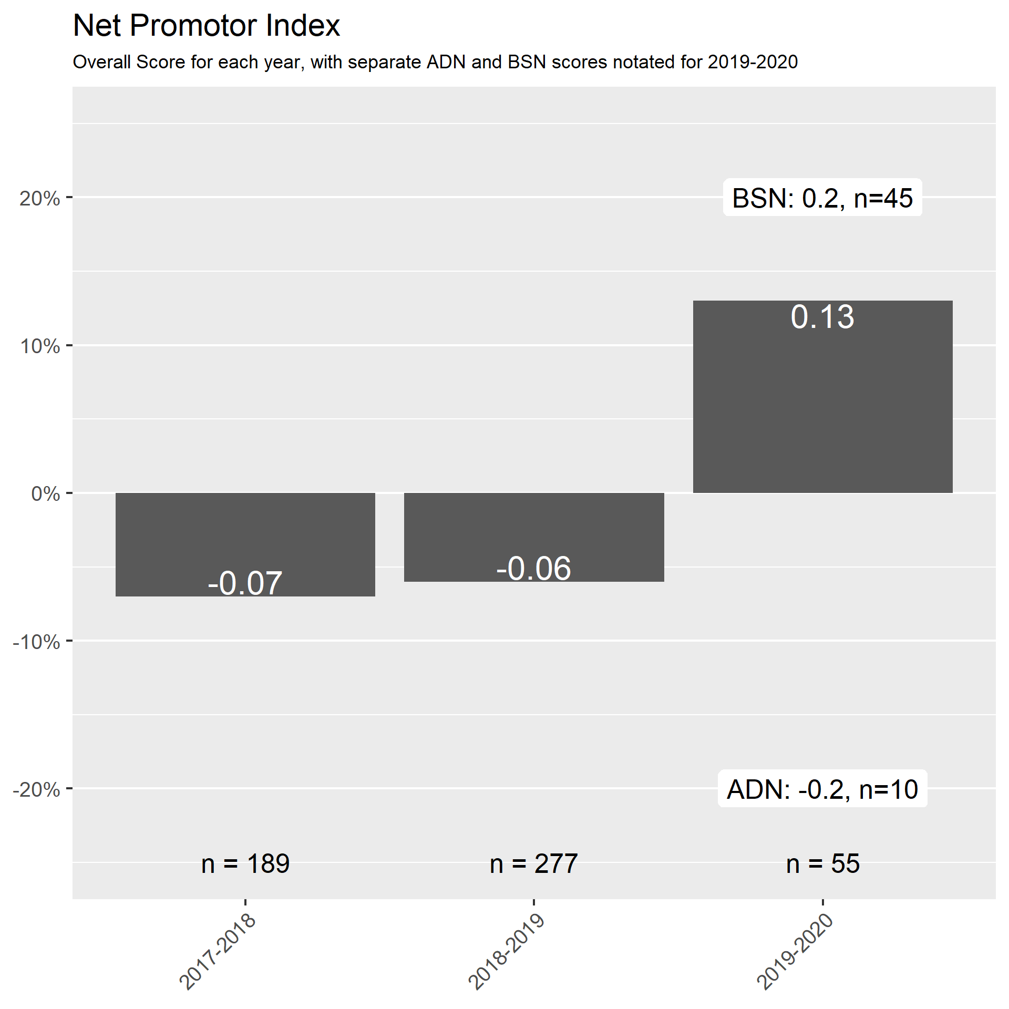
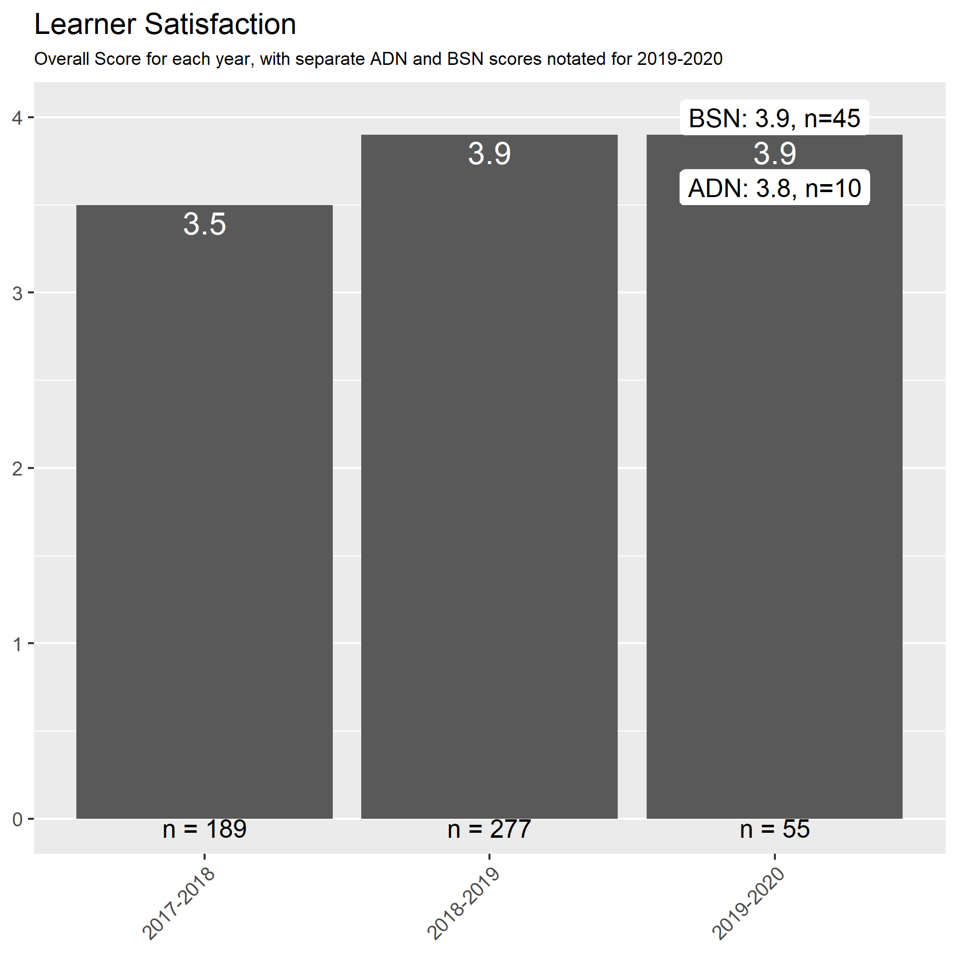
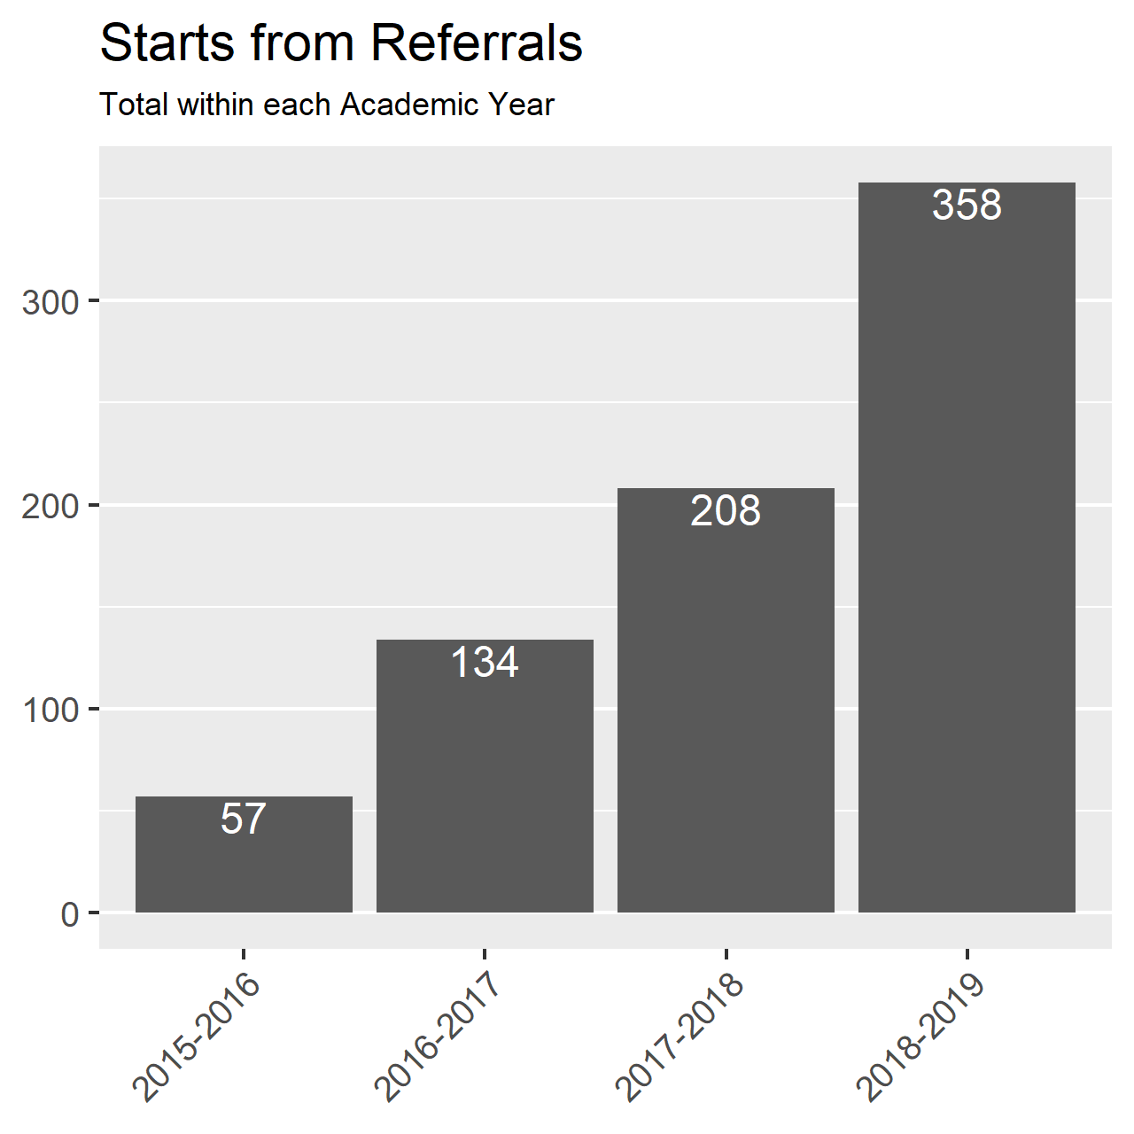
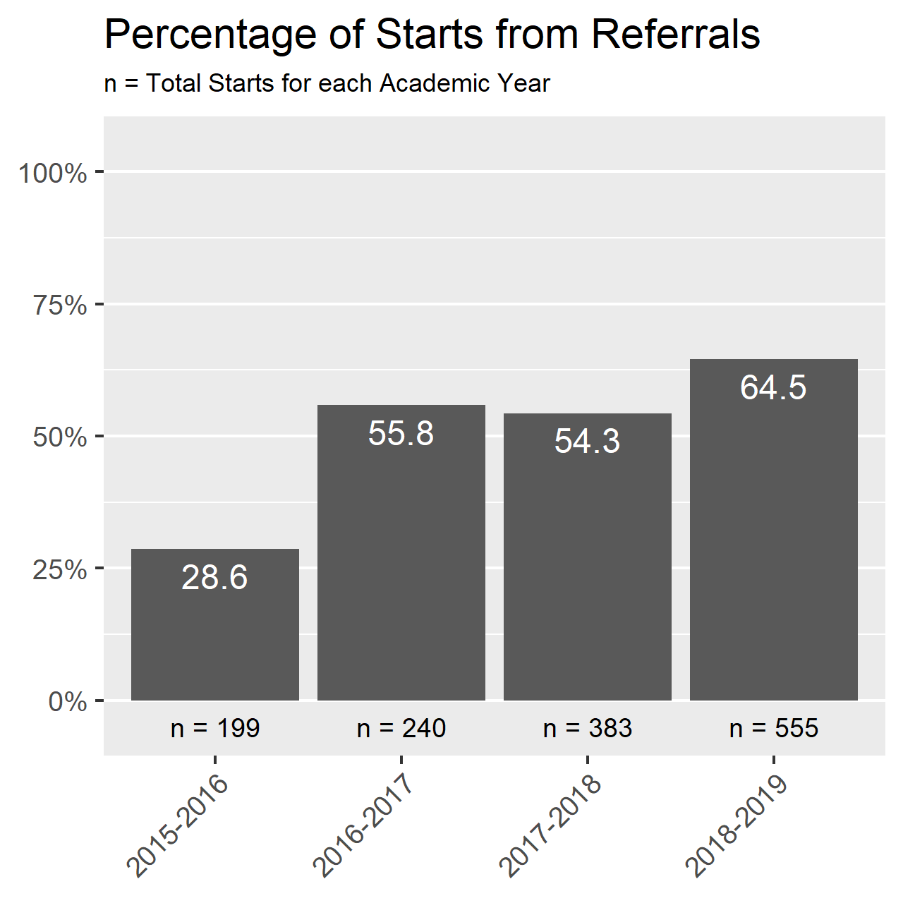

SUMMARY/ANALYSIS
- NPI
  - Prompt: Based on your experience over the current semester, how likely would you be to recommend Nightingale College to a friend, family member, or colleague?
  - Answers: Likert Scale, 5 = Definitely would recommend thru 1 = Definitely would not recommend
  - Promotor = Definitely would recommend, Neutral = Would recommend, Detractor = Maybe, would not, or definitely would not recommend
  - $\frac{Promotors-Detractors}{Promotors+Detractors+Neutral}$
  - Definition/calculation changed between 2016 and 2017, to push our goal to ‘definitely would recommend’, rather than just ‘would recommend’
  - We showed a big increase overall so far for 2019-2020.
  - ADNs much less likely to recommend, which is not surprising given our program changes.

- Program Satisfaction
  - Prompt: Rate your experience with Nightingale College for each subject
  - Answers: Likert Scale, 5 = Very satisfied thru 1 = Very dissatisfied
  - Our average satisfaction scores are holding steady, very near to an average score of 4, ‘satisfied’.
- Starts from Referrals
  - Starts from Referrals used instead of Total Referrals, because we have tracked Starts much more consistently.
  - Chart shows the totals only. Still working on a way to better visualize with all DDCs.
  - Our first figures for 2019-2020 will be available soon and will be added

ACTION PLAN
- Add referral levels, broken down by DDC.
- For 2019-2020, add Continuance program over program as an additional metric in the coming year, baseline data.
GOAL
- NPI – 0

Institutional Effectiveness Plan
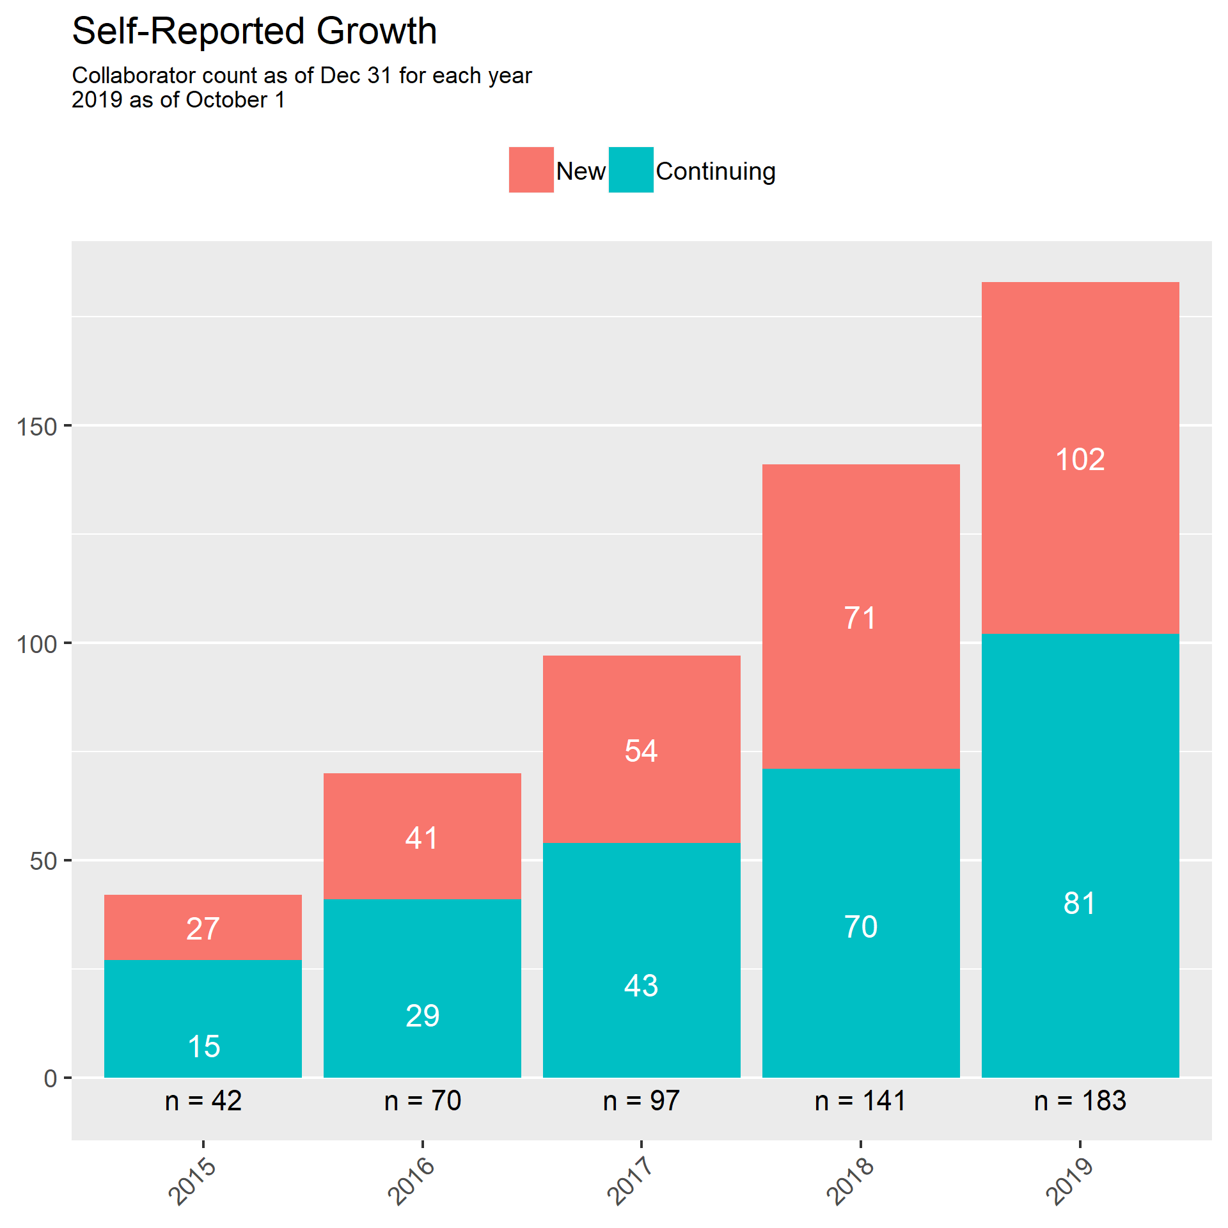
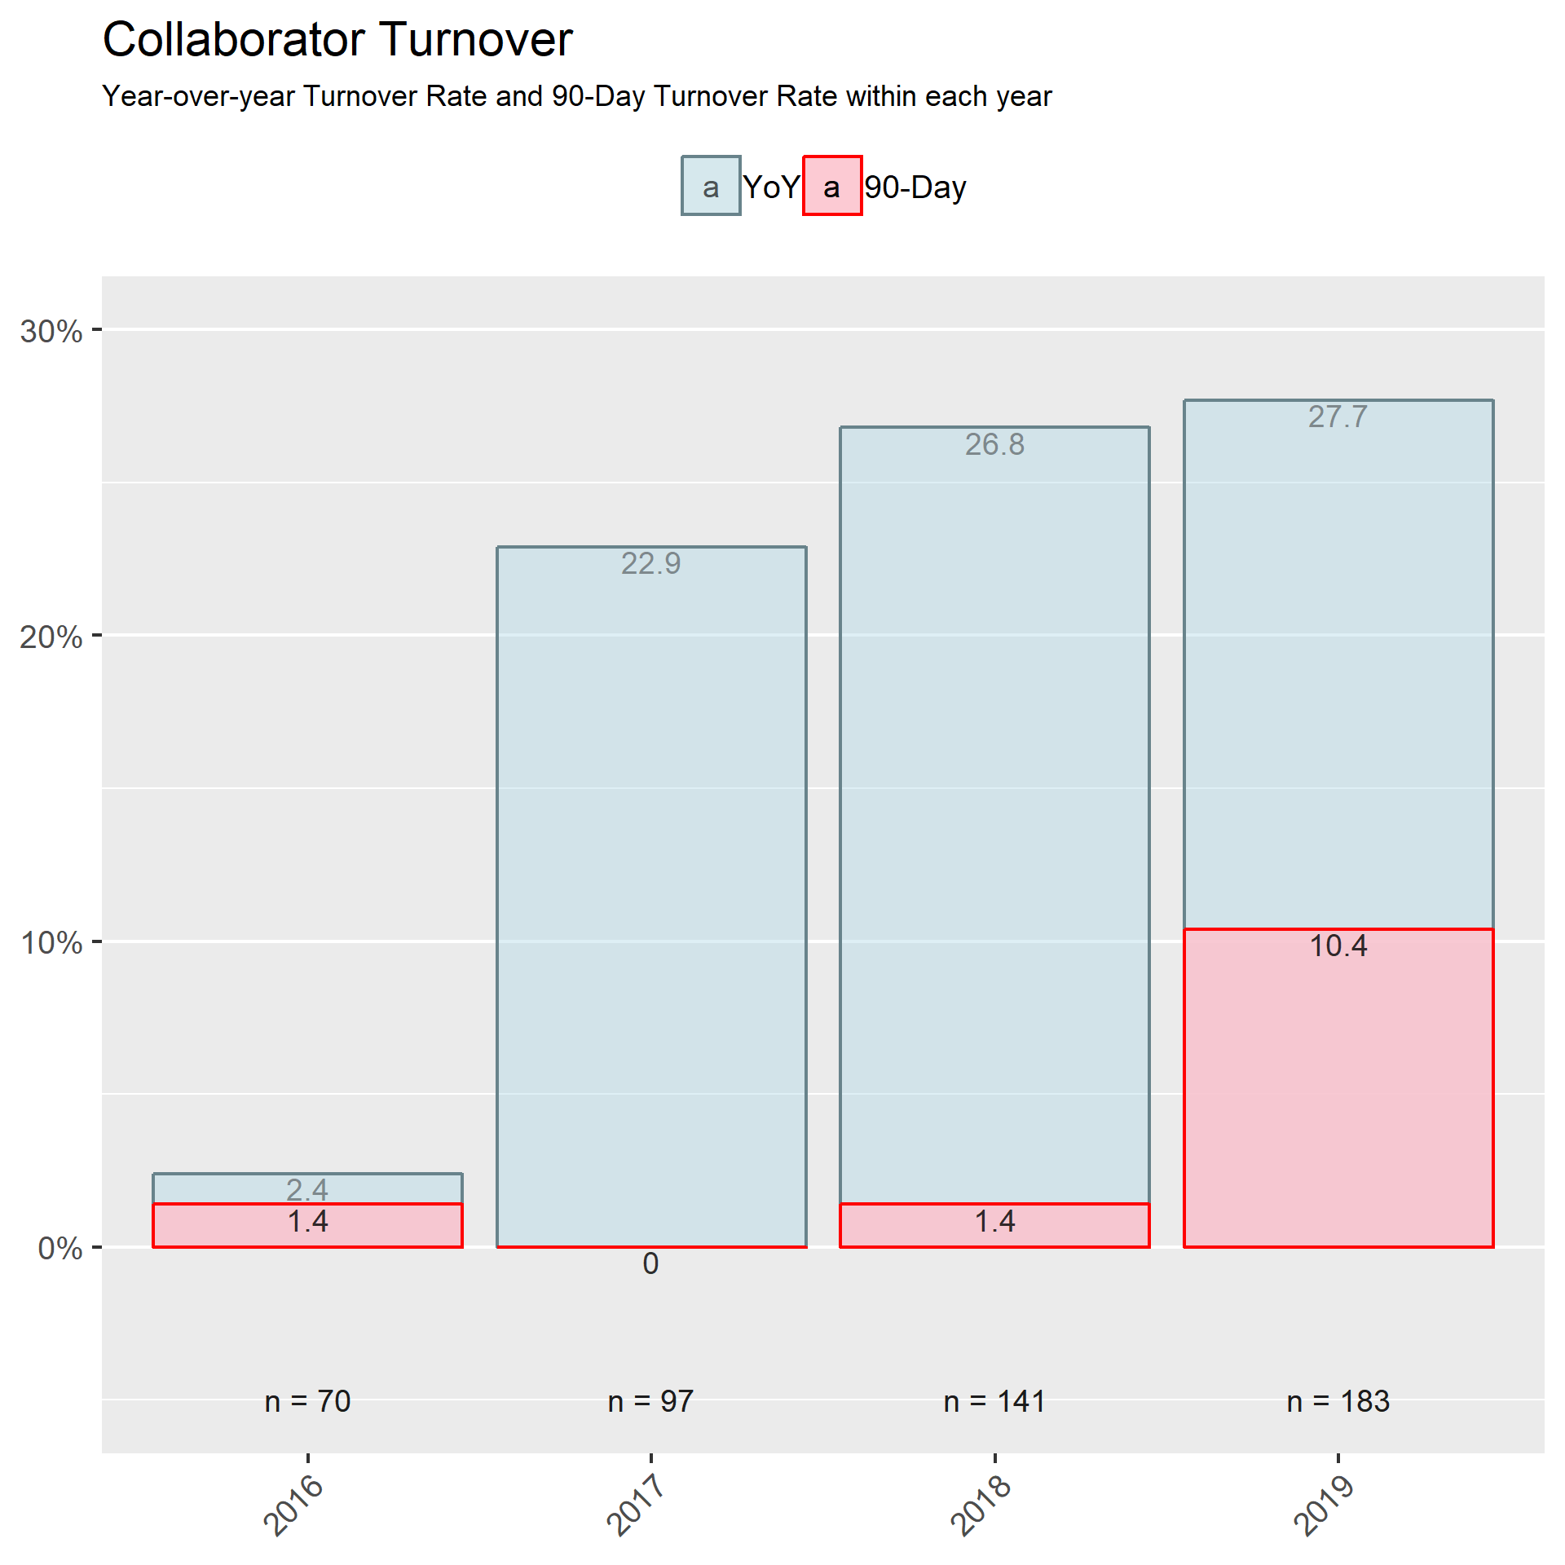
SUMMARY/ANALYSIS
- No change yet since Fall IEP.
- Calculated for each year, as of Dec 31 (As of October for 2019).
- We have been growing fast, and with that have come some growing pains.
- This year especially we have seen a much higher 90-Day Turnover Rate.

ACTION PLAN
- Focus renewed on selection process to improve/reduce 90-day turnover rate
- Moving to engage a recruiting partner to support our interview and hiring process
- Continued focus on “right-sizing” individual functions and alignment process
- Focus on solidifying new frameworks from the current year into the collaborator experience
GOAL
- YoY Turnover Rate – 20%
- 90-Day Turnover Rate – Not enough information yet

Institutional Effectiveness Plan
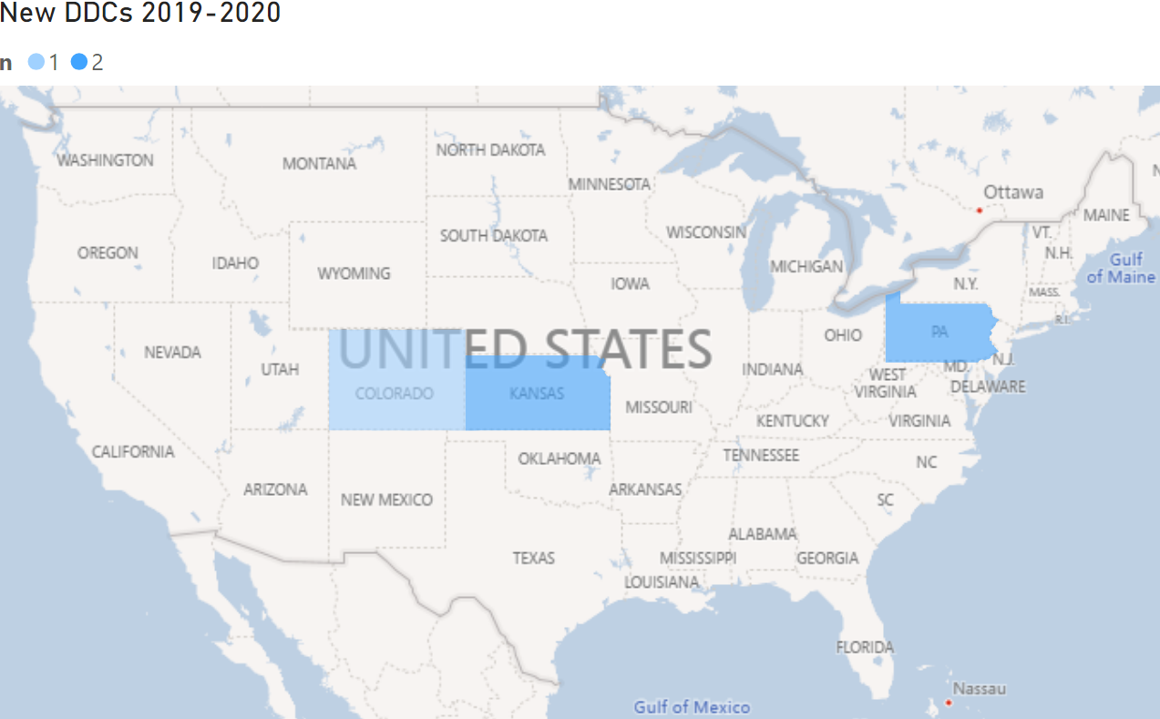
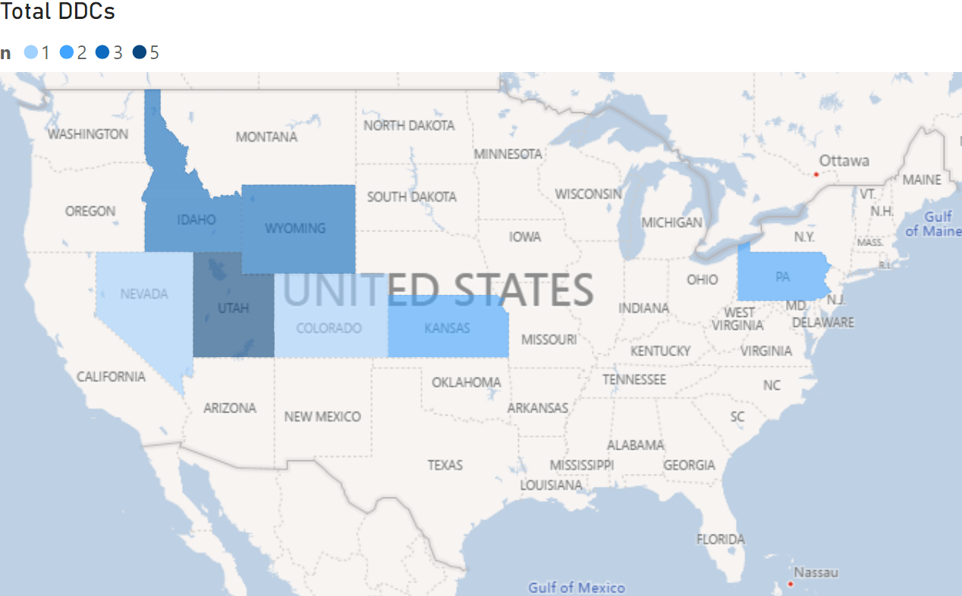
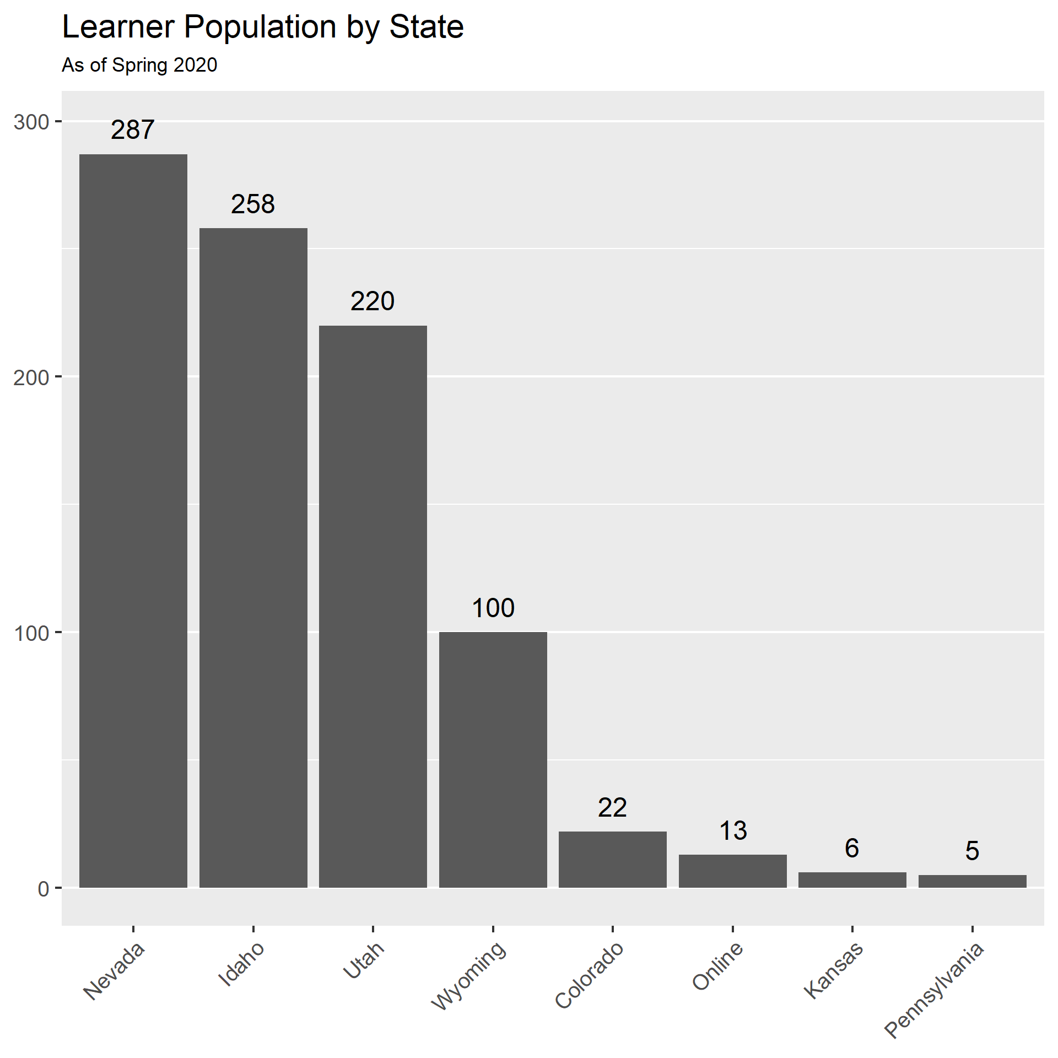
SUMMARY/ANALYSIS
- 2019-2020 DDCs added so far:
  - Colorado Springs, CO
  - Dodge City, KS
  - Manhattan, KS
  - Lancaster, PA
  - DuBois, PA
- Upcoming for Summer 2020
  - Anchorage, AK
  - Boulder, CO
  - Ames, IA

ACTION PLAN
- Breakout by states we operate in.
- Looking to include a DDC scorecard in the coming year to also indicate the health and service provided in that DDC location.
GOAL
- Not enough information to set meaningful goals by tier

